STATE UNIVERSITY OF MEDICINE AND PHARMACY
„NICOLAE TESTEMIŢANU”

The Department of Topographic Anatomy
and Operative Surgery
Association of Medical Students and Residents
14 – 17 octomber 2014
Basic Surgical Skills
The Third Edition
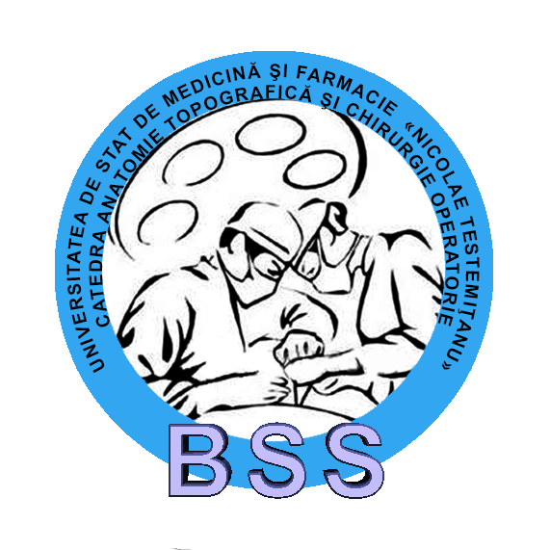

Chișinau, 2014
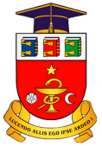
THE ORGANIZING COMMITTEE:
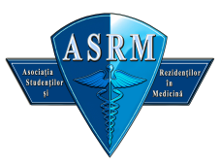
Coordinators:
Boris Topor – MD, PhD, Prof., Head of Department
Viorel Nacu – MD, PhD, Professor
Serghei Suman – MD, PhD, Associate Professor
Radu Turchin – MD, PhD, Associate Professor
Gheorghe Guzun – MD, PhD, Associate Professor
Sergiu Visnevschi – MD, Assistant Professor

Mentors and trainers:
Coltug Oleg, resident-surgeon, MA
Coșciug Stanislav, resident-trauma, MA
Josan Andrei, resident-urologist, MA
Oprea Victor, resident-surgeon
Eșanu Andrei, student
Ojog Sergiu, student
Toncoglaz Constantin, graduate student
Toncoglaz Sergiu, graduate student
Caprovoi Stanislav, student
Zamisnii Isidor, student
Sirițanu Irina, student, head of of ASR projects
Scerbatiuc Corina, student, vice-presedent of ASR
Buruiană Gheorghe,student, member of ASR

GOALS:
- To provide students the opportunity to enlarge their theoretical knowledge in the field of surgery;
- To learn gestures and basic surgical maneuvers on biological materials;

- At the same time, creating a relaxedand professional atmosphere, helping to fulfill the educational goals which will allow the medical students to socialize, to work in teams and to establish friendships or future collaboration in projects.

PROGRAM:
Day I (Octomber 14, 2014, Wednesday)
Time 3:30 p.m. – 6:30 p.m.
- Aseptic and antiseptic measures in the OR.
- Presentation of basic surgical instruments.
- Bandages and dressings

Day II (Octomber 15, 2014, Thursday)
Time:3:30 p.m. – 6:30 p.m

- Local anestesic
- Wound management
- Types of surgical sutures
- Surgical knots

Day III (Octomber 17, 2014, Friday)
Time:3:30 p.m. – 6:30 p.m.
- Principles of hemostasis
- Elements of vascular surgery

Day IV (Octomber 18, 2014, Saturday)
Time: 9:00 a.m. – 1:30 p.m.

- Crico-, conicotomia
- Digestive surgery
- Intestinal anastomoses, intestinal resections

Handing out diplomas!

SPEACIALITY:

The project "BASIC SURGICAL SKILLS" provides the opportunity for 20 students (of the III-VI year) and young residents to shape and improve their skills and handling the basic surgical equipment.

Since surgery requires teamwork, the 20 participants, which will be arranged in pairs at 10 work tables. All the participants will be supervised by 10 trainers and teachers, they will be watched and guided in carrying the shown techniques.

NB! This project takes puts an emphasis on surgical practice basic maneuvers, starting with the simplest and continuing gradually toward more complex maneuvers. Each technique is repeated until all participants are familiar with it.

The "BASIC SURGICAL SKILLS, The 3rd Edition" consists of 4 modules (approximately 5 hours each), which will take place 15/10/14 – 18/10/2014.
Each module consists of a seminar that includes both theoreticaland practical lessons that are mixed with each other.

The Theoretical Courseswill consist of planning the same day courses. On account of the basic concepts and principles for that theme.

The practice consists of demonstrations of the trainers. Their instructions are followed step by step by the participants that will work at their tables. The demonstrations are filmed and presented in real time.

Participants, under the guidance of instructors will teach how to handle the surgical instruments, will perform surgical knots, will perform sutures on biological material (plain, continuous etc.), intestinal and vascular sutures.

GENERAL RULES:

Article I - Conditions for participation:
- Participants must be III-VI year students of the State University of Medicine and Pharmacy „Nicolae Testemiţanu”
- Participants are required to complete the application form without omitting any fields, not false, at least two weeks before starting the project. Participants are required to pay the fee at that date and time default by organizing committee.

Article II - Participation at the workshop of surgical techniques:
- The participation at the 4 modules is obligatory.
- The absence is not permited.
- Participants are requiredto follow the workshop program.
- The participants are required to wear the (surgical suit).
- Participants are required to follow the rules for their own protection. The organizers are not responsible for accidents occurring while handling surgical instruments by participants.
- Participants will behave appropriately, maintain clean work tables and will not damage furniture, surgical instruments and simulators.
Article III

- If a student wishes to withdraw his participation, he must notify the organizing committee representatives at least 7 days before the workshop. The organizing committee will return 75% of the fee. Ifthe period of seven days is not met, the fee will not be refunded.
- If a participant violates these regulations, penalties can range up to retain the degree of participation.

THE PARTICIPATION FEE

The participation fee is 300 LEI:

The fee will be paid only after confirmation of acceptance of the participant within 72 hours of confirmation receipt.

The fee covers:

- Participation in the theoretical and practical courses
- Coffee break
- Course supplies (sutures, needles, scalpel blades, gloves, etc.)
- Portfolio for work + book + pen + badge
- Certificate of participation

GOOD LUCK!

